Truro School
Sports Day

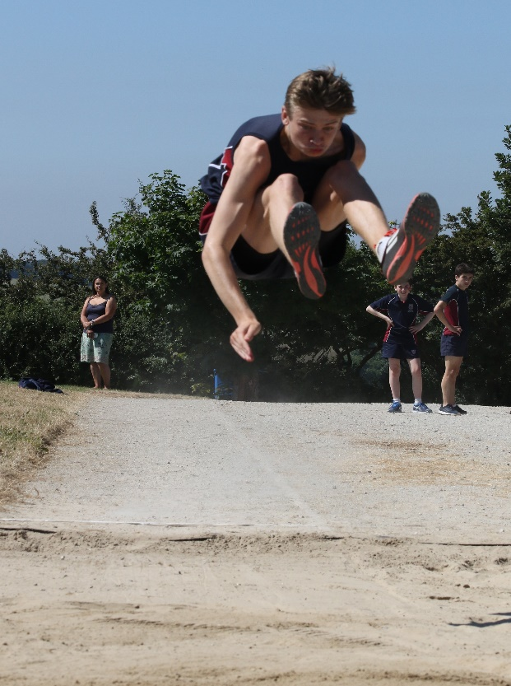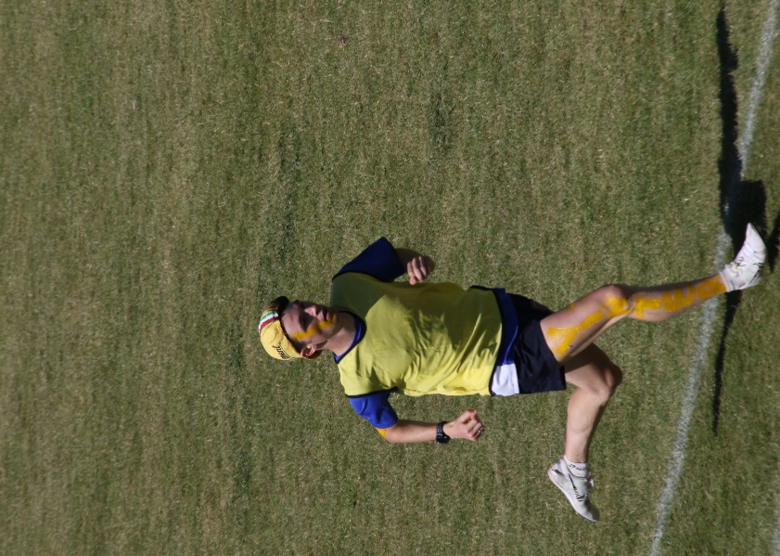
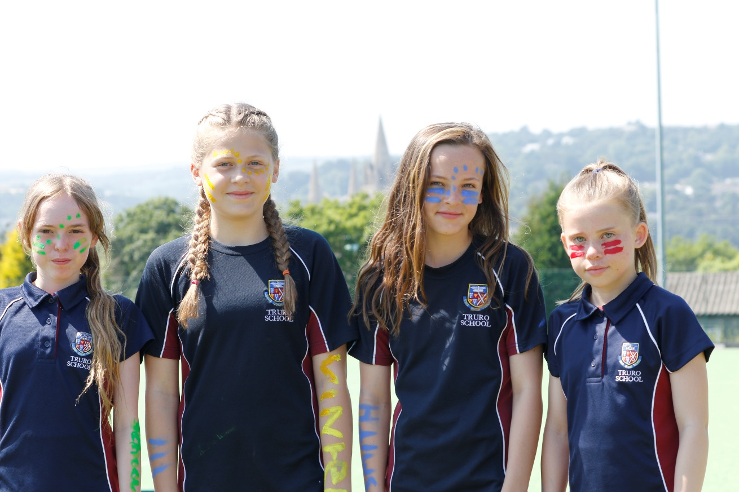
27 June 2019

Field Events Timetable

Block 1  9.30am – 10.00am | Block 5  11.30am – 12.00pm
- 1st Year Girls Long Jump  - 1st Year Boys Triple Jump  - 2nd Year Girls High Jump (area 2)  - 2nd Year Boys Shot (area 2)  - 3rd Year Girls Discus (area 1)  - 3rd Year Boys Javelin (area 1)  - 4th/5th Year Girls Javelin (area 2)  - 4th/5th Year Boys Shot (area 1)  - Sixth Form Boys Discus (area 2)  - Sixth Form Girls High Jump (area 1) | - 2nd Year Girls Long Jump  - 3rd Year Girls Shot (area 2)  - 3rd Year Boys High Jump (area 2)  - 4th/5th Year Girls Triple Jump  - 4th/5th Year Boys Discus (area 1)  - Sixth Form Girls Javelin (area 2)  - Sixth Form Boys High Jump (area 1)
Block 2  10.00am – 10.30am | Block 6  12.00pm – 12.30pm
- 2nd Year Girls Javelin (area 1)  - 2nd Year Boys Long Jump  - 3rd Year Girls Javelin (area 2)  - 3rd Year Boys Discus (area 2)  - 4th/5th Year Girls Shot (area 2)  - Sixth Form Boys Triple Jump | - 1st Year Girls High Jump (area 2)  - 1st Year Boys Javelin (area 1)  - 2nd Year Girls Shot (area 1)  - 2nd Year Boys Discus (area 2)  - 3rd Year Boys Long Jump (TJ Pit)  - 4th/5th Year Girls High Jump (area 1)  - 4th/5th Year Boys Javelin (area 2)  - Sixth Form Boys Long Jump
Block 3  10.30am – 11.00am | Block 7  12.30pm – 1.00pm
- 1st Year Girls Discus (area 1)  - 1st Year Boys Shot (area 2)  - 2nd Year Boys High Jump (area 2)  - 3rd Year Girls Long Jump  - 4th/5th Year Girls Discus (area 2)  - 4th/5th Year Boys Triple Jump  - Sixth Form Girls Shot (area 1)  - Sixth Form Boys Javelin (area 2) | - 1st Year Girls Shot (area 2)  - 1st Year Boys Discus (area 1)  - 2nd Year Boys Javelin (area 1)  - 3rd Year Girls High Jump (area 1)  - 4th/5th Year Girls Long Jump  - Sixth Form Girls Triple Jump
Block 4  11.00am – 11.30am | Block 8  1.00pm – 1.30pm
- 1st Year Girls Javelin (area 1)  - 1st Year Boys High Jump (area 1)  - 2nd Year Girls Discus (area 1)  - 3rd Year Boys Triple Jump  - 4th/5th Year Boys Long Jump  - Sixth Form Girls Discus (area 2)  - Sixth Form Boys Shot (area 1) | - 3rd Year Boys Shot (area 1)  - 4th/5th Year Boys High Jump (area 2)  - Sixth Form Girls Long Jump  - 2nd Year Boys Triple Jump.

Track Events Timetable

Time | Race | Competitors
9.00am | House meetings around track
9.25am | Assemble at your first event
9.30am – 10.00am | 100m | 1st, 2nd & 3rd Year Boys and Girls
10.00am – 10.20am | 100m | 4th/5th Year & Sixth Form Boys and Girls
10.20am – 11.00am | 800m | 1st, 2nd & 3rd Year Boys and Girls
11.00am – 11.20am | 800m | 4th/5th Year & Sixth Form Boys and Girls
11.20am – 12.00pm | 200m | 1st, 2nd & 3rd Year Boys and Girls
12.00pm – 12.30pm | 200m | 4th/5th Year & Sixth Form Boys and Girls
12.30pm – 1.00pm | 400m | 3rd 4th/5th Year & Sixth Form Boys and Girls
1.00pm – 1.40pm |  | Lunch Break
1.40pm – 1.50pm | All competitors to gather around  the track for the relays
1.50pm – 3.35pm | Relays | All Years
3.35pm – 3.45pm | All competitors to gather around the  track for the results

