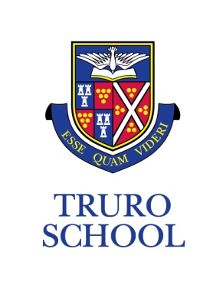

MFL Department Information

The MFL department provides students at Truro School with an amazing opportunity to develop and achieve excellence in their linguistic skills. The Modern Languages Department aims to equip students with the lifelong ability to communicate with others in a foreign language and experience cultural diversity.

Current Department Staffing

The department consists of five full-time members and one part-time member of staff each bringing immense experience and different language specialisms as well as passion for their subjects. The department staff are proud of their history of teaching language students and supporting students at GCSE and A level to achieve their best and enjoy language learning. Members of staff are expected to teach across at least two languages and up to A Level in at least one.

The department also benefits from having three language assistants who provide support for the students in preparation for their speaking exams and support for the staff. They are mainly involved with pupils studying GCSE and A Level, but also assist at lunchtimes with our co-curricular activities and our after-school clubs.

Department meetings take place at regular intervals throughout the term.

Department Facilities

The department currently is located in a contained classroom block with:
- 6 full classrooms, one equipped as an ICT suite
- 2 smaller seminar style rooms often used for A level and GCSE teaching, one of which is also an ICT suite
- Large departmental office with work space for all department staff
- Smaller rooms for language assistant work

Current Curriculum

1st Year – 3rd Year

In the 1st Year all students study French and German, giving them a sound foundation in language learning.
In the 2nd Year students continue with both French and German and are set in language groups based on their level of achievement
In the 3rd Year students can learn French, German or Spanish. They have the option to study one, a combination of any two, or all three.

French, German and Spanish at GCSE level

In the 4th Year, all students are encouraged to study at least one language and can currently choose from French, German and Spanish. Students can choose to study two or even three in any combination. At GCSE level, all students follow the CIE IGCSE course in their chosen language(s). Students have additional support from the team of language assistants.

French, German and Spanish at A Level

In the Sixth Form, French, German and Spanish are offered at A Level and currently follow the AQA examination specifications. This includes weekly one-to-one conversation lessons with fluent language assistants, extensive ICT and multimedia facilities. The department has previously arranged work experience placements in France and Germany which immerse our sixth formers both in the language and the culture of the country. In Spanish, students have taken part in a 6th form study trip which enhances the context of their A Level studies.

Class sizes at A level vary from cohort to cohort, with typically between four and eight students studying each language.

Exam Results

At A level, each subject often performs at 4 or above (Very Good or Excellent) as judged by the A Level performance system with the department achieving high percentages of A*-C.

At GCSE, students have consistently achieved at or above nationally standardised residuals over the period of the last 5 years.
The percentage of the top Grade A* students in the exam results from the summer of 2018 were 5.7%, 28.7 % and 13.2% in French, German and Spanish respectively with 40%, 78.8% and 44.7% achieving A* or A respectively.

Enrichment/Co-Curricular Activities

The department has extended its language provision by offering a programme of trips and exchanges. Currently the department has undertaken or plans to undertake the following:
- French trip (3rd - 5th Year) - Nice
- German trip - Munich
- Spanish trip to be relaunched (4th - 5th Year)
- German trip - Berlin

The department also offers extra lunchtime and after-school sessions for able linguists, and has established “Gifted and Talented” lunchtime classes. The department enhances its provision through translation competitions; routes into languages competitions; the Oxford University Olympiads, and creative writing competitions.

Deputy Head (Academic)
February 2019

