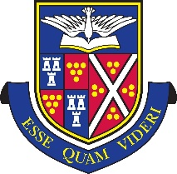
Bus Timetables 2018/19

St Ives Bus Service

AM | Monday - Friday
St Erth -  Saltings Park and Ride Car Park Lelant | Departing | 07.35
Hayle – McDonald’s | Departing | 07.42
Camborne – Premier Inn | Departing | 07.50
Prep School | Arriving | 08.15
Senior School – Old Sports Hall | Arriving | 08.35

PM | Monday - Thursday |  | Friday
Prep School | Departing | 16:50 | 15.45
Senior School – Old Sports Hall | Departing | 17.15 | 16.05
Camborne Premier Inn | Arriving | 17.45 | 16.30
Hayle – McDonalds | Arriving | 17.52 | 16.37
St Erth -  Saltings Park and Ride Car Park Lelant | Arriving | 18.00 | 16.45

- Children must be at the bus stop 5 minutes prior to the scheduled departure time.
- All timings are subject to traffic conditions
- Bus timings will be monitored and revised if necessary to ensure pupils arrive in school on time.

